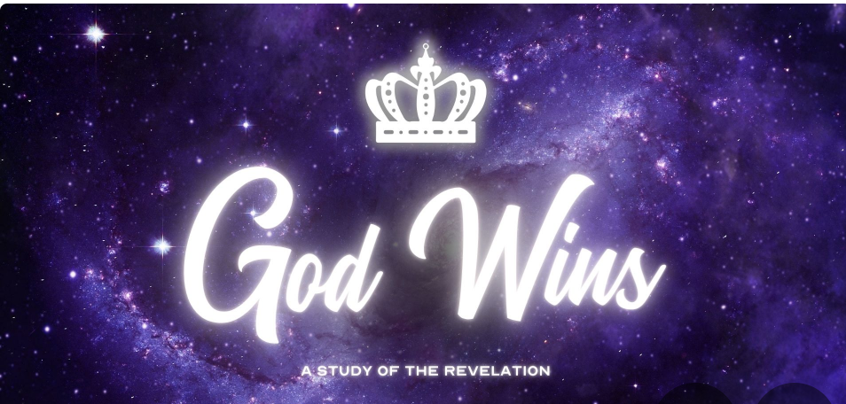

Revelation 19 Overview

The New Testament contains an abundance of insights about the return of Christ, making it impossible to cover everything in a brief blog post. Thus, I will focus solely on Revelation 19:11-21 in this article. This passage vividly depicts the identity of Jesus and the implications of his second coming, especially for those who do not believe.

(1) The anticipation of Christ's return is not merely a theological concept but a cornerstone of Christian hope. The New Testament resonates with this theme, emphasizing its centrality to believers. Paul, in Romans 8:22-25, frames it as the fulfillment of our adoption and redemption. Similarly, in 1 Thessalonians 4:13-18, he offers solace to those grieving by pointing towards the hope of Christ's return. Titus 2:13-14 underscores this expectancy, labeling it as our "blessed hope." Peter echoes this sentiment in 1 Peter 1:13, urging believers to anchor their hope in the grace revealed at Christ's revelation.

The profound impact of this hope is outlined in 1 John 3:2-3, where John highlights its purifying influence. The prospect of seeing Christ face-to-face serves as a spark for personal transformation, driving us towards purity and conformity to Christ's likeness. It's a journey of sanctification fueled by the anticipation of encountering the Savior, rendering sin repugnant in light of his imminent return.

(2) In Revelation 19, the imagery of Christ's return is vivid and symbolic, depicting him riding a white horse (19:11). While this imagery might seem perplexing when contrasted with other biblical descriptions, it's essential to grasp its symbolic significance. The white horse symbolizes triumph and sovereignty, portraying Christ as the ultimate victor leading his followers to conquest. Rather than fixating on literal interpretations, the focus should be on the overarching message of Christ's triumph and reign.

(3) The portrayal of Christ as "Faithful and True" in Revelation 19 underscores his role as both judge and warrior (19:11). His judgment is not arbitrary but rooted in righteousness, contrasting sharply with the flawed justice of human rulers. This depiction reaffirms Christ's commitment to justice and truth, ensuring that his judgment is just and impartial. Furthermore, his judgment extends not only to unbelievers but also serves to defend and vindicate his people against all forms of unrighteousness (Revelation 19:11).

(4) The imagery of Christ adorned with many diadems symbolizes his unparalleled authority and kingship. Unlike earthly rulers whose dominion is limited, Christ's sovereignty transcends all boundaries, affirming his status as the ultimate cosmic king. The multitude of diadems underscores his supremacy over all earthly powers, emphasizing his unrivaled reign as "King of kings and Lord of lords” (Revelation 19:12).

(5) The mysterious name written on Christ, known only to himself, speaks to the unfathomable depths of his being. This mysterious inscription highlights the incomprehensible nature of Christ's character and essence, surpassing human understanding. In ancient contexts, knowledge of one's name signified power and control. By retaining his name's secrecy, Christ maintains sovereign authority over his adversaries, beyond their grasp or manipulation (Revelation 19:12).

(6) The imagery of Christ's robe dipped in blood evokes his sacrificial death on the cross, symbolizing redemption and atonement. Additionally, his designation as "the Word of God" underscores his role as the divine mediator, embodying and proclaiming God's truth. Through his words and actions, Christ reveals the essence of God's character, serving as the ultimate expression of divine revelation and authority (Revelation 19:13).

(7) The heavenly armies accompanying Christ symbolize the culmination of God's divine purpose and victory. Comprised of angels, believers, and martyrs, this celestial host bears witness to Christ's triumphant return. Their presence signifies solidarity with Christ in his mission of redemption and judgment, aligning with biblical narratives of divine intervention and deliverance (Revelation 19:14).

(8) The sharp sword emanating from Christ's mouth symbolizes the power of his word to execute judgment and establish his reign. His rule, known by righteousness and sovereignty, stands in stark contrast to the oppressive regimes of earthly rulers. By treading the winepress of God's wrath, Christ asserts his authority over all nations, fulfilling his title as "King of kings and Lord of lords" (Revelation 19:15).

(9) Contrary to popular belief, the second coming of Christ does not entail the removal of believers from tribulation but their participation in his victorious return. Paul's writings in 1 Thessalonians 4 and Philippians 3 outline the sequence of events, emphasizing the transformation and resurrection of believers. Rather than escaping suffering, believers will accompany Christ in his final triumph over evil and establishment of his kingdom (1 Thessalonians 4:13-18).

(10) The judgment depicted in Revelation 19 signifies the ultimate defeat of Christ's enemies and the vindication of God's righteousness. Symbolic imagery, such as the feast of birds on the flesh of the slain, underscores the severity of divine judgment. While the specifics may elude literal interpretation, the message remains clear: all will be held accountable before God, and his justice will prevail eternally (Revelation 19:17-18; Rom. 14:12).

++++++++++

What does this section in Revelation 19:11-21 teach us, in part?

1. Staying Hopeful in Waiting: Just as I eagerly await the return of Christ, I'm reminded to keep my faith strong and my hope alive, knowing that he will come back for me exactly when he's meant to (19:11).

2. Knowing Righteousness Will Prevail: When I feel overwhelmed by the darkness in the world, I find solace in the image of Jesus as the victorious warrior. It assures me that no matter how bleak things may seem, righteousness will always triumph over evil (19:11).

3. Treasuring the Word of God: The sword that comes from Jesus' mouth reminds me of the power and authority of Scripture. It encourages me to immerse myself in God's Word daily, letting it guide my thoughts, words, and actions (19:15).

4. Acknowledging Jesus as Ultimate Authority: Seeing Jesus adorned with many crowns reinforces my belief that he is the King of Kings and the Lord of Lords. It challenges me to submit every aspect of my life to his authority and to live in obedience to his teachings (19:16).

5. Finding Peace in God's Sovereignty: Even in the midst of chaos and conflict, I take comfort in knowing that God is ultimately in control. The victory belongs to him, and I can trust in his wisdom and power to navigate through life's challenges (verse 17).

6. Reflecting on the Judgment of Evil: The defeat of the beast and the false prophet reminds me of the consequences of opposing God. It prompts me to examine my own heart and ensure that I'm walking in alignment with his will, lest I face a similar fate (19:19-21).

7. Holding onto Hope in Dark Times: In moments of despair, I cling to the promise of Revelation 19:11-21—the assurance that God’s holiness and good will ultimately triumph over evil. It's a beacon of hope that guides me through life's storms, reminding me that God's justice will prevail in the end (verses 19-21).

